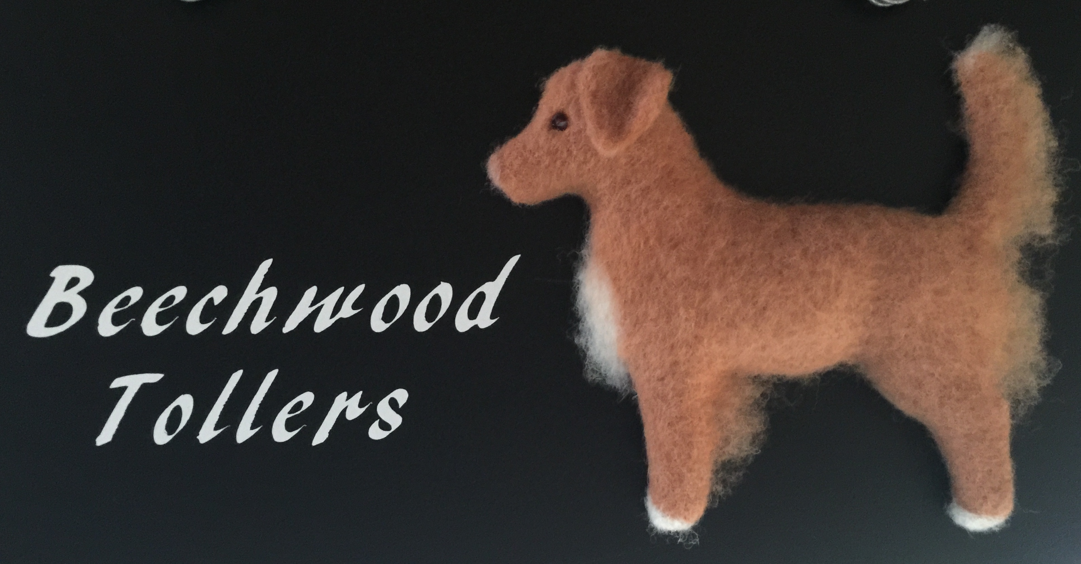
Thank you for your interest in a puppy from Beechwood Tollers. We started our journey into the Toller World in 2001 with a dog named Eddy bred by Alison Strang of Westerlea Kennels. Since that time we’ve had the good fortune to be mentored by Alison Strang author of the Toller Book as well as many top competitors in the obedience, agility, field and conformation venues. As members in good standing of the USA and Canadian National Toller Clubs our goal is to breed healthy, well tempered dogs that meet the breed standards as set by the National Clubs.
Because Tollers are active, intelligent dogs, which need a great deal of exercise and mental stimulation, they are not for everyone. If you will please take the time to answer the following questions it will help you and us to assess whether or not a Toller is the best breed for you. Please use an extra sheet of paper to add other relevant information or to ask any questions that you may have.

Marie and John Simonson
2196 NW Beechwood Place
Corvallis, Oregon 97330
541-752-0693 - H
541-740-2363 - C

Potential Puppy Buyer Survey
Name:
Address:
Phone:
E-mail:
Age:

- Why are you interested in a Toller; what attracted you to this breed?

- How did you learn about Tollers and Beechwood Tollers?

- Are you working with any other breeder or on a list for a puppy, elsewhere?
Yes ___ No___
If so, with whom are you dealing?

- Are you interested in a male_______ female_____ no preference ____
Or are you willing to take whichever pup fits you’re your lifestyle regardless of gender?

- Would this be your first Toller?

- What will you use your Toller for? Hunting _____ Hunt Tests_______
Show_____ Obedience____ Agility_____ Therapy Dog_____ Family Pet_____

- Will you neuter/ spay? If not, why not?

- Have you met other Tollers? Explain your reaction to them, please:

- Where will the pup stay during the day?

- How long will the pup be alone?

- Where will the pup stay during the night?

- Do you plan to use a crate/kennel for your pup? Yes____ No____

- Are you prepared to provide all necessary veterinary treatment, including all annual vaccinations, feed high-quality dog kibble, license your Toller and make sure that your dog is well socialized?

- List previously owned dogs, breed, age and cause of death:

- Are there any other pets in the home now? If yes, please describe:

FAMILY DATA:
While we realize that the following may contain questions you may not feel comfortable answering, please keep in mind the fact that a pup is a lifelong investment. There are logical reasons why we ask; since we place these pups for life. It is our hope that by knowing more about you and your lifestyle, we can more appropriately place our puppies, and meet your pet’s needs. If you feel a question is too personal, leave it blank.

Are you M _____ S ______ D _____
Your age: 20's ____ 30's____ 40's____50's ____ 60's____

Occupation of adult(s)

Who will the pup be sharing a home with?

Who will primarily care for the dog?

If there are children at home, what are their ages?

Is someone home during the day? Yes _____ No____
If not what arrangements would you make for your new pup?

Do you: Own your home _____/ Rent a house_____/ Apartment_________
Do you live in an Urban_______ Suburban_____ or Rural setting_______?

Do you have a securely fenced yard?
If not, are you willing to install fencing? If not, why not?

Do you understand you are making a commitment for the entire life of this dog, which could be up to 15 years? Yes____ No____

Will you be willing to join either the US NSDTR Club or Canadian NSDTR Club?
Yes____ No____ (Memberships include a quarterly publication)

Activities

How active is your lifestyle?

Are you aware that most Tollers are active dogs and need to be exercised on a daily basis?

What activities will you plan to meet its needs?

Are you willing to attend puppy socialization and/or obedience classes?
If not, why not?

What books have you read on dog training?

In order for our waiting list to remain current, please be sure to let us know as soon as possible if you should get a puppy elsewhere or change your mind. Thank you for taking the time to answer these questions. We look forward to hearing from you.
Regards,
Marie and John

Please return the form by e-mail to: mailto:BeechwoodTollers@gmail.com?subject=Potential Puppy Buyer Survey

Additional Notes:

